CS 333 APPLICATION SOFTWARE DEVELOPMENT LAB

**MINI PROJECT REPORT**

**Student Management System**

SUBMITTED BY

1. LINITHA SUNNY, 19, SEMESTER 5, CSE
2. LYDIA RACHEL JOSEPH, 21, SEMESTER 5, CSE
3. MANNA ANN MARIYAM, 22 ,SEMESTER 5, CSE
4. SHERIN JOHN,50,SEMESTER 5, CSE
5. WINNY ANNA VARKEY,64 ,SEMESTER 5, CSE

SAINTGITS COLLEGE OF ENGINEERING

DEPARTMENT OF COMPUTER SCIENCE AND ENGINEERING



DECEMBER 2020

Table of Contents

Abstract 3

Chapter 1: Introduction 4

Chapter 2: Technical Design 5

Chapter 3: Challenges faced during implementation 7

Chapter 4 : Screenshots 8

REFERENCES 31

**Abstract**

Students form a main part of any institution that concerns with. But the institutions find it difficult to keep details of so many students of the organization just in one stretch. It will involve a lot of pen paper work. Sometimes there will be some huge heap of files bundled up and kept together in some corner of the office. If you want any information regarding the particular student then it can be obtained by just entering the roll number or the name of the student to be searched. This student management system will make the work of storing the data in an organized way.

The student management system application will help in managing the student’s reports, results and exams will become easier with one such system. It will also help in saving time and effort. The user interface must be user friendly and easy to understand. The information of the particular student will be obtained in just one mouse click.

**Chapter 1: Introduction**

The objective of Student Management System is to allow the administrator of any organization to edit and find out the personal details of a student and allows the student to keep up to date his profile .It will also facilitate keeping all the records of students, such as their id, name, mailing address, phone number, DOB etc. So all the information about an student will be available in a few seconds.Overall, it'll make Student Information Management an easier job for the administrator and the student of any organization.

The main purpose of this SRS document is to illustrate the requirements of the project Student Management System and is intended to help any organization to maintain and manage its student's personal data.Without a Student Management System, managing and maintaining the details of the student is a tedious job for any organization.Student Management System will store all the details of the students including their background information, educational qualifications, personal details and all the information related to their resume.

**Chapter 2: Technical Design**

1.ER DIAGRAM

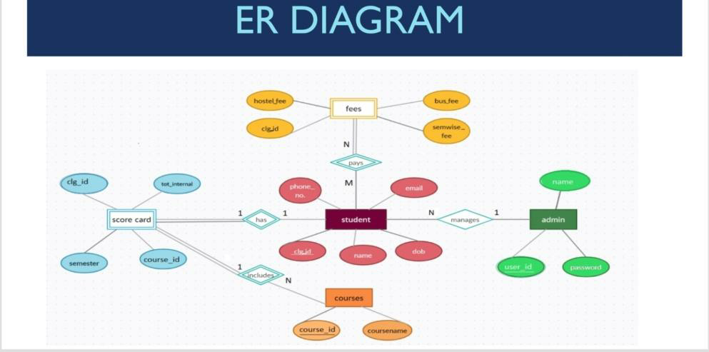

2.SCHEMA

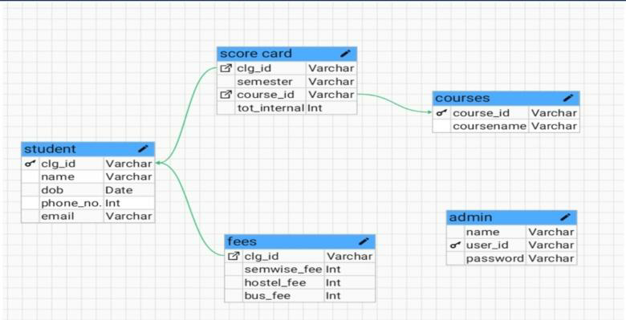

**Chapter 3: Challenges faced during implementation**

1. Internet Connectivity

This was a major issue during the implementation of student management system. Since SMS is web based ,a good connectivity is needed so that the system could be provided with all the support that it needs.

1. Lack of Knowledge about New Language

The main programming language we used was PHP. Since we did not have much knowledge about that language, we faced certain errors. Due to this, the process was also time consuming.

1. We faced some challenges.During insertion of database tables and while performing the query over these database tables we faced some challenges.

4) Difficulty when creating large database.

Chapter 4 : Screenshots

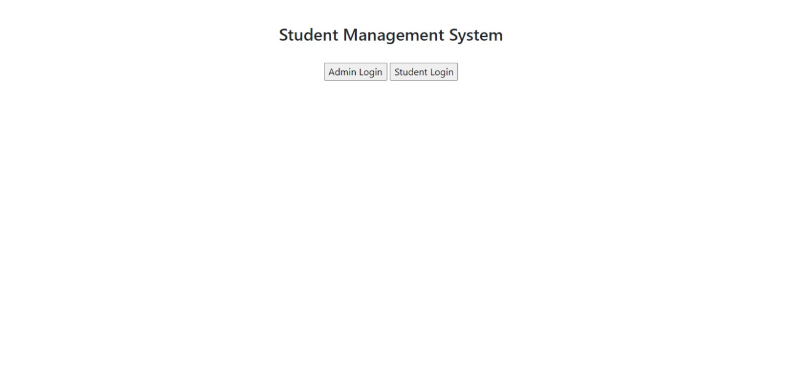

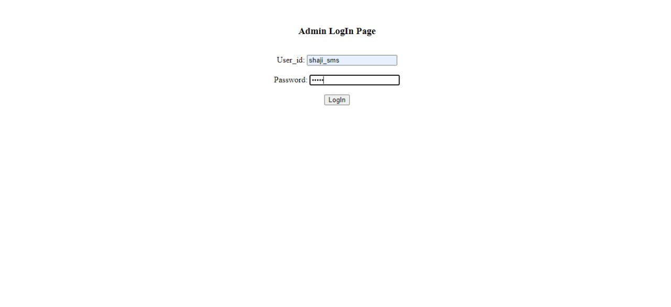

Admin dashboard

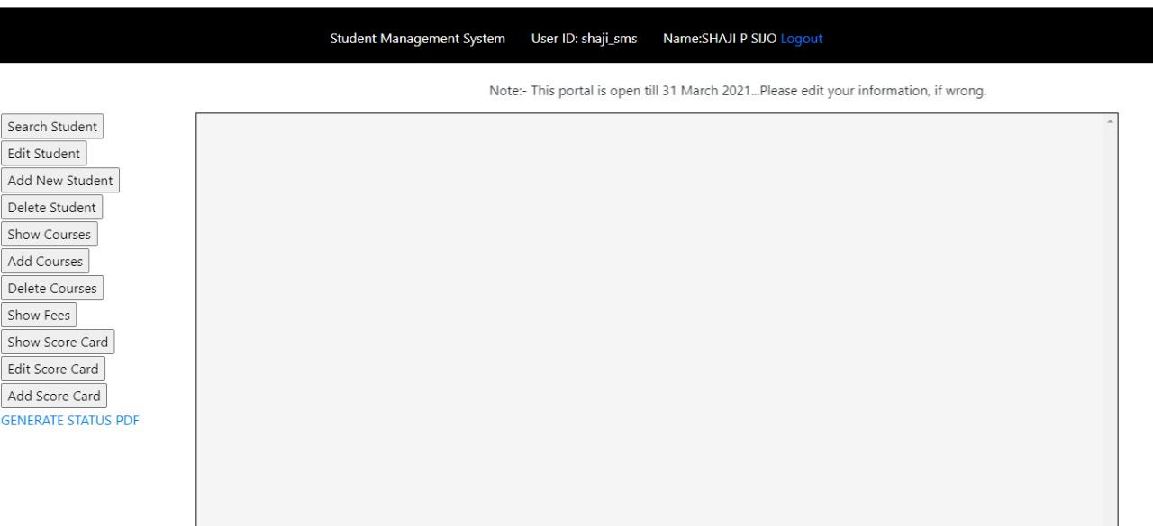

Search student 1

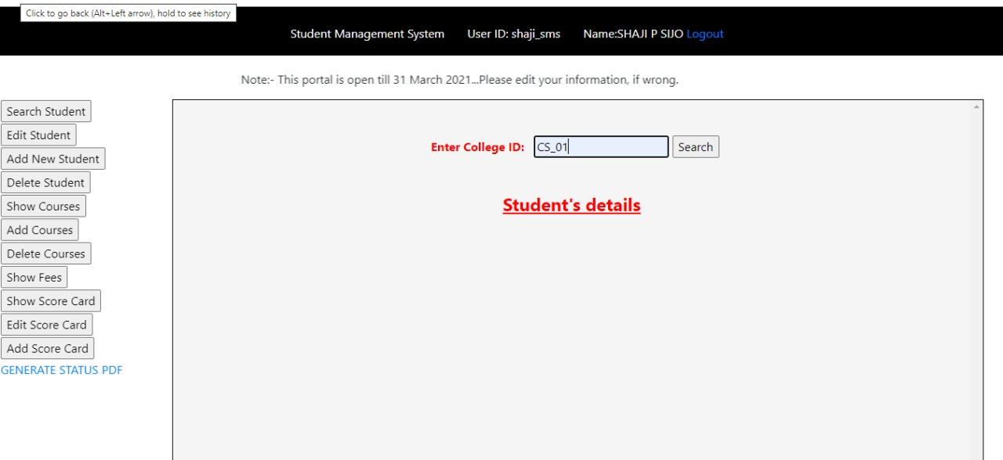

Search student 2

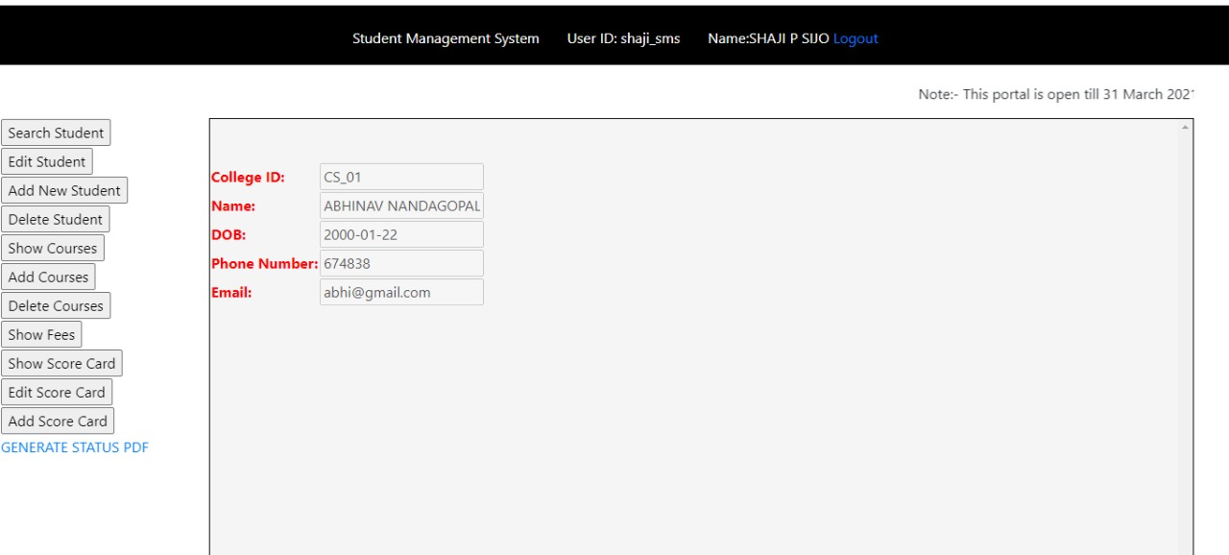

Edit student 1

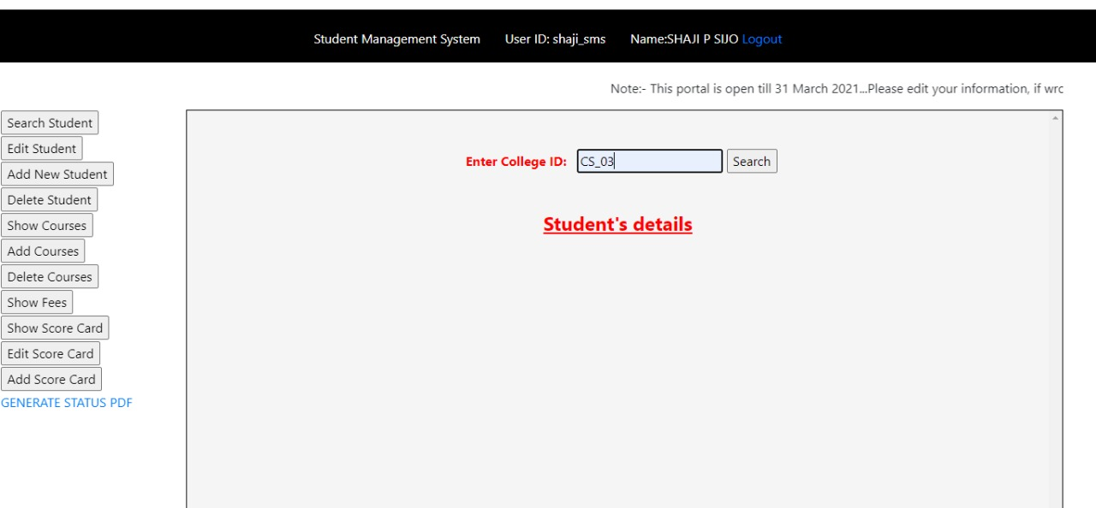

Before edit

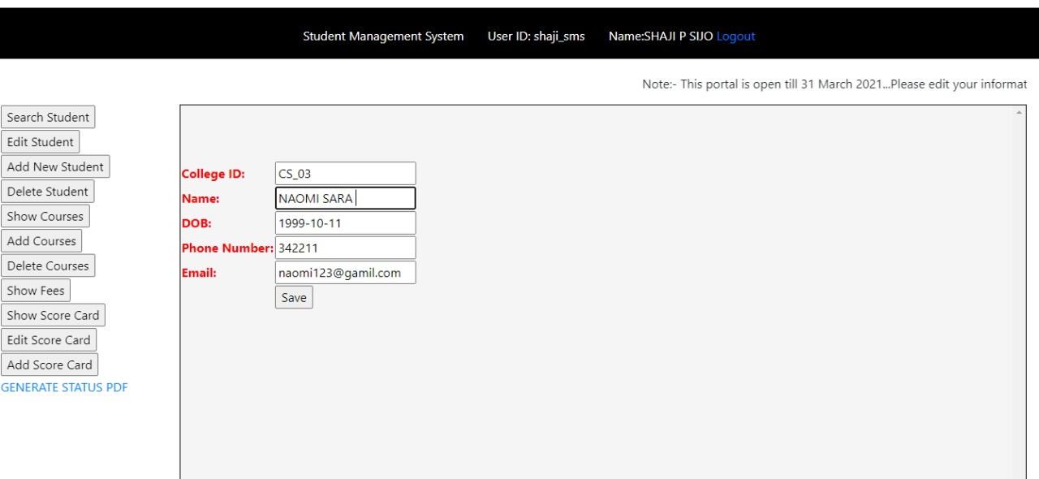

Changes made

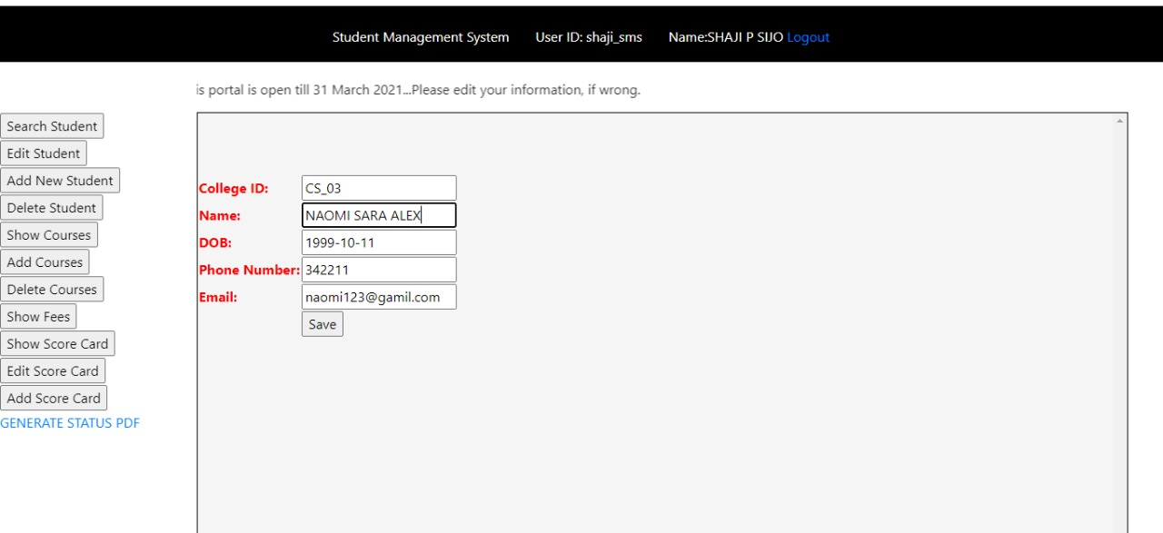



Database before

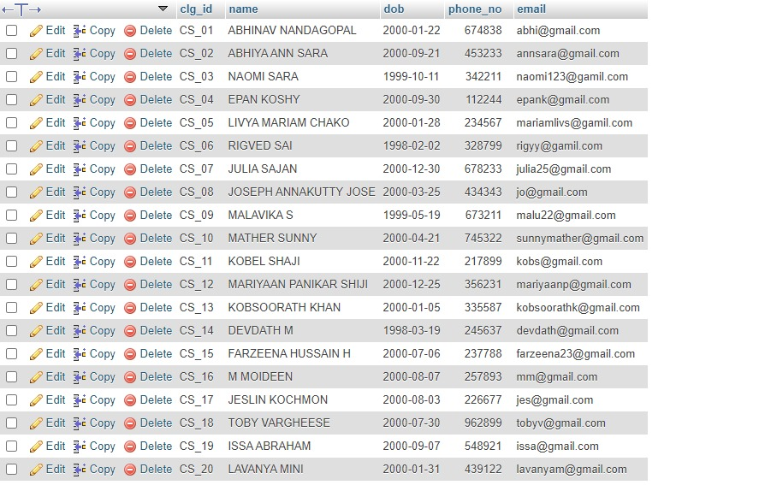

Database after edit

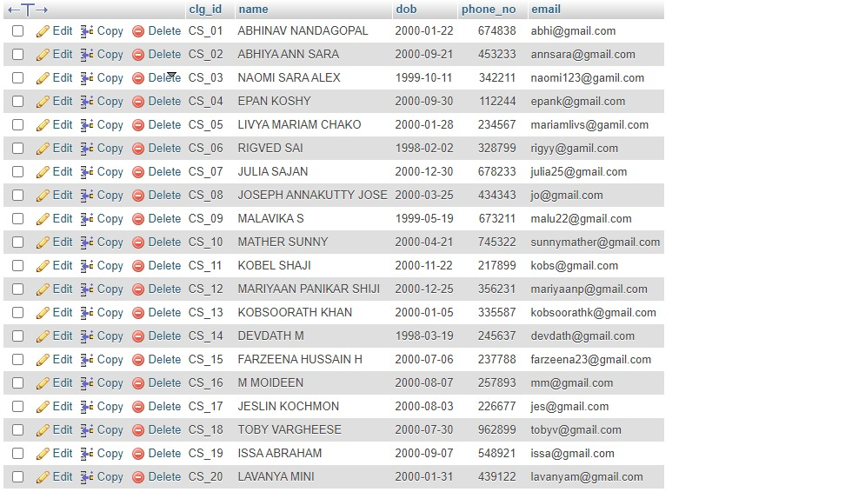

Add student

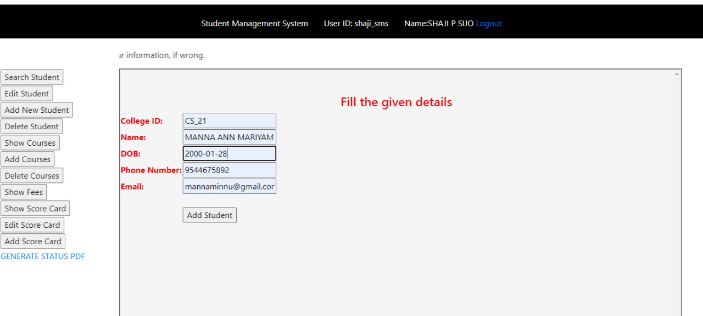



Database before

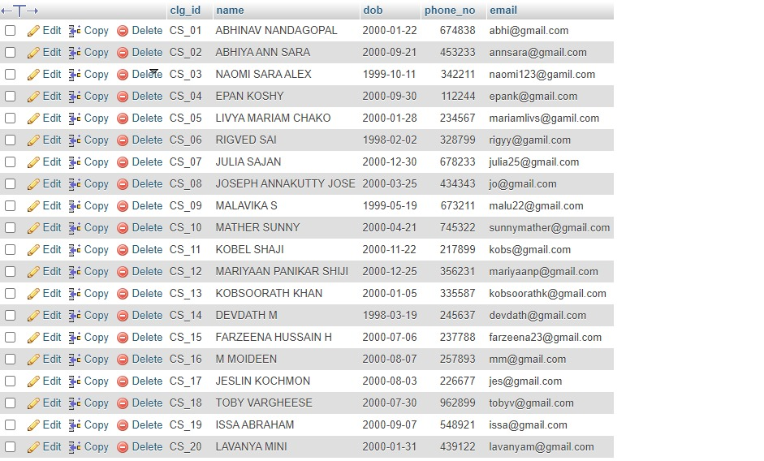

Database after

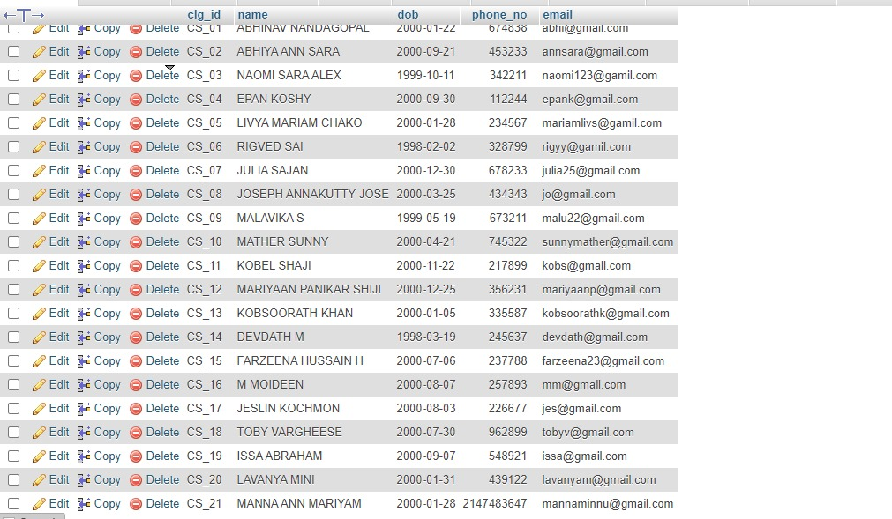

Delete student

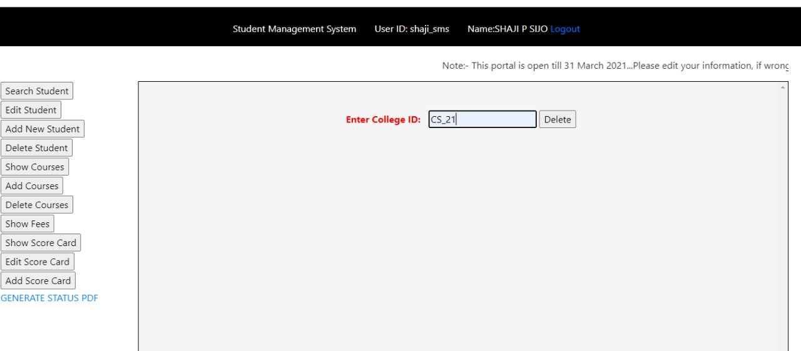



Database before

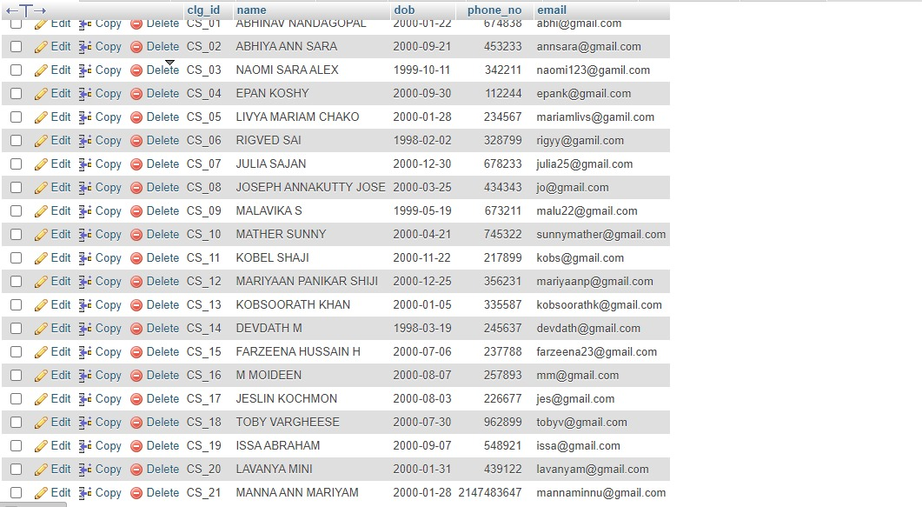

Database after

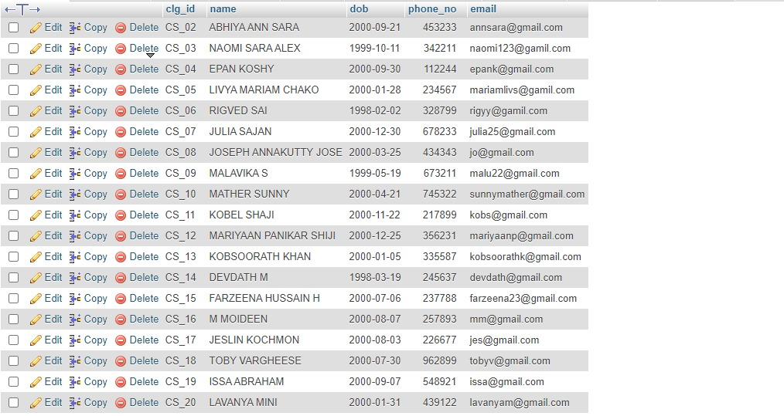

Show course

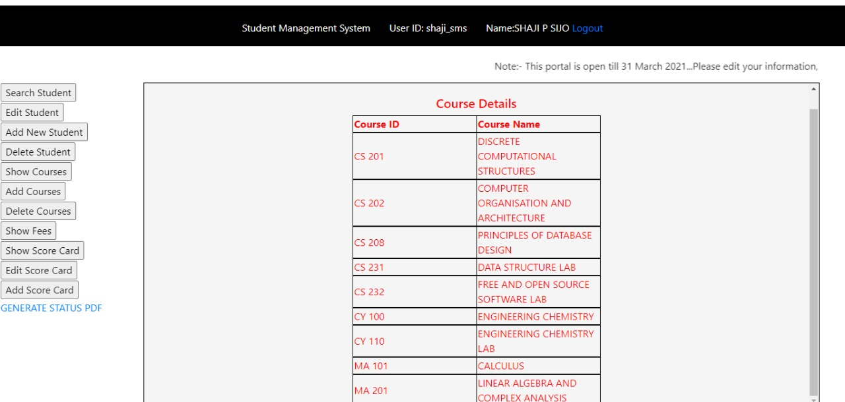

Add course

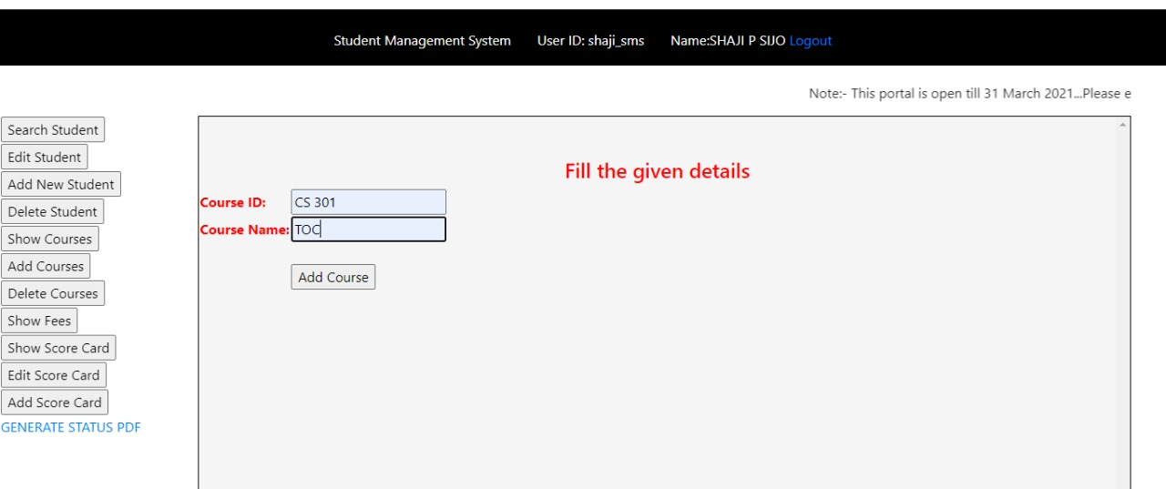



Database before

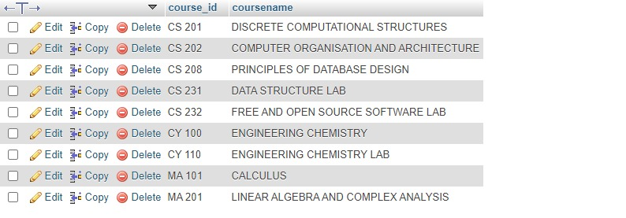

Database after

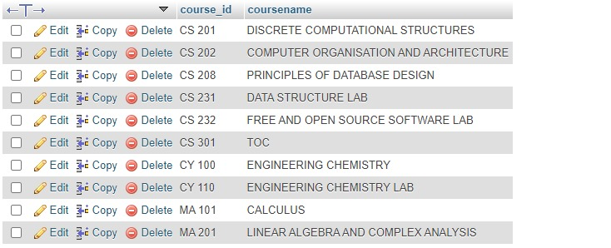

Delete course

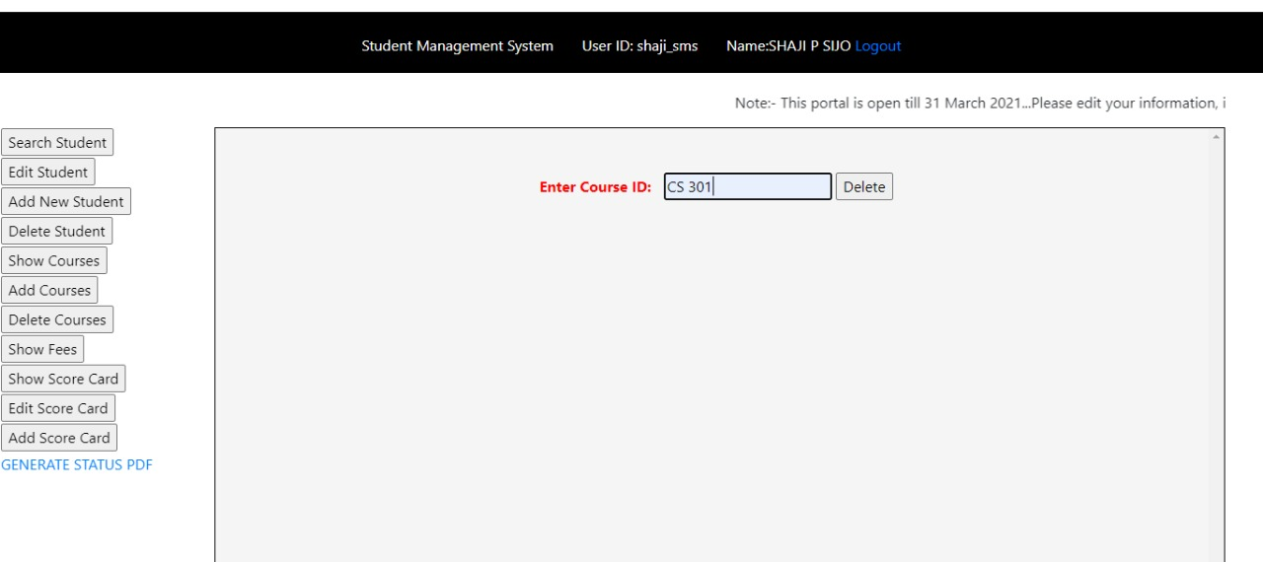

Database before

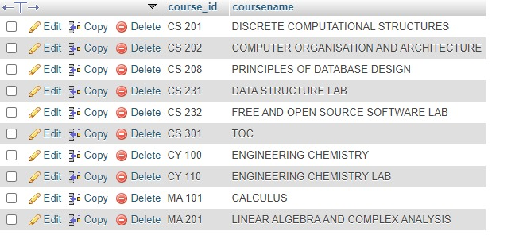

Database after

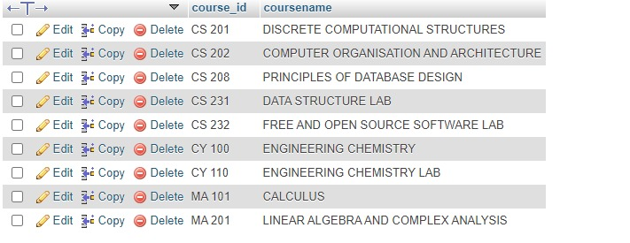

Show fees

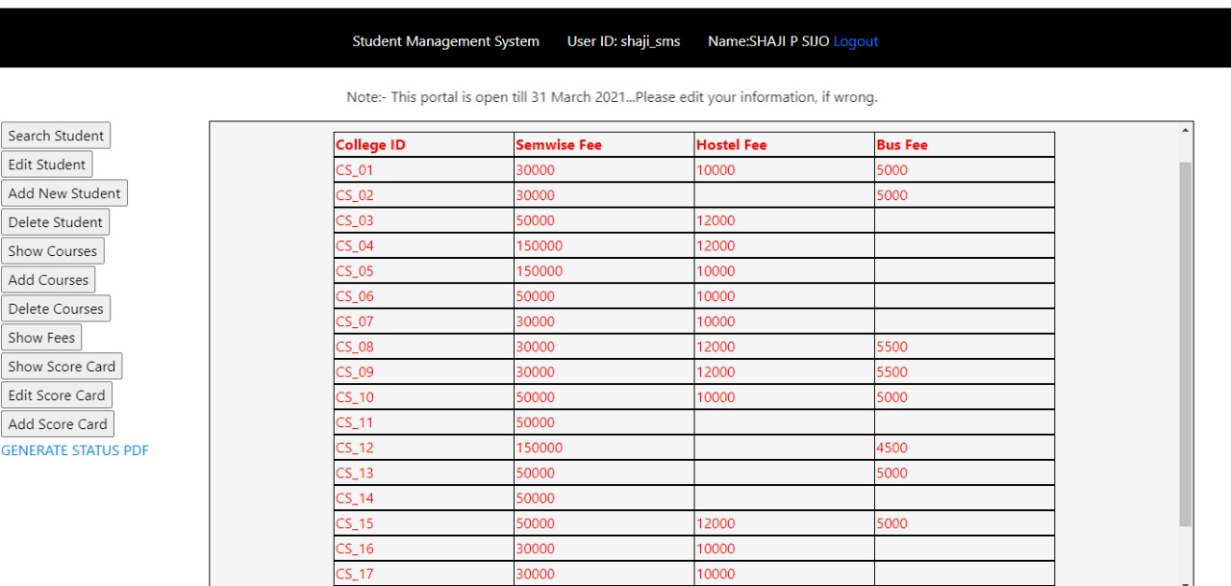

Show Score card

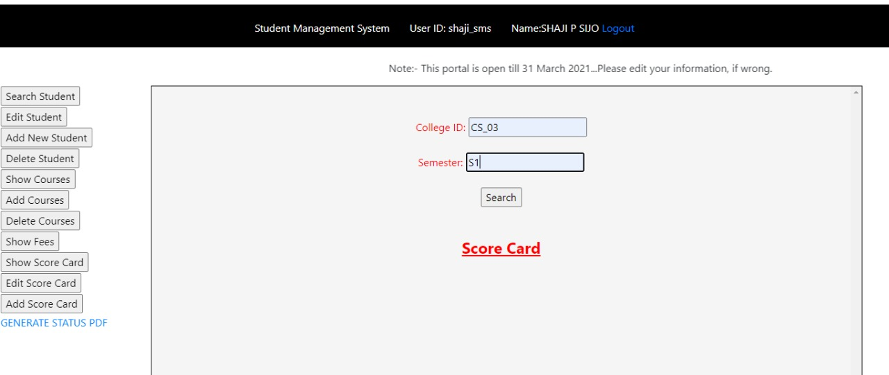

Show Score card 2

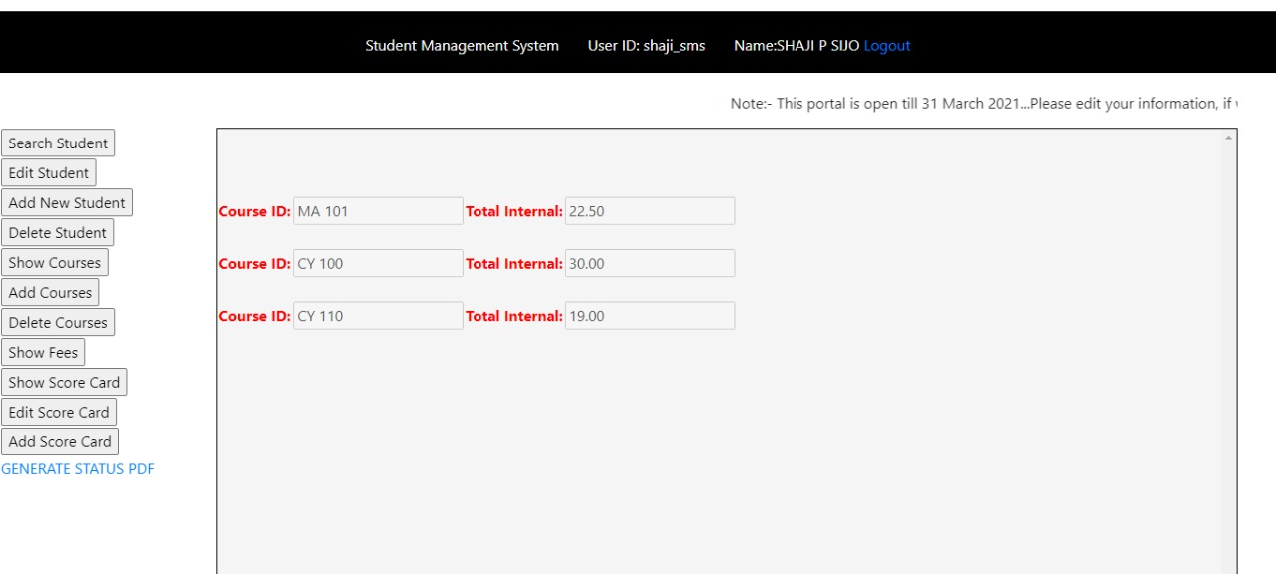

Edit Score card 1

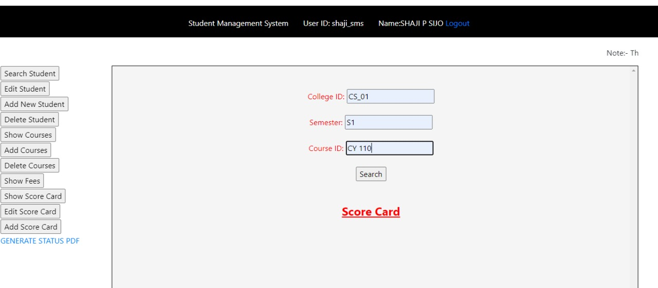

Edit Score card 2

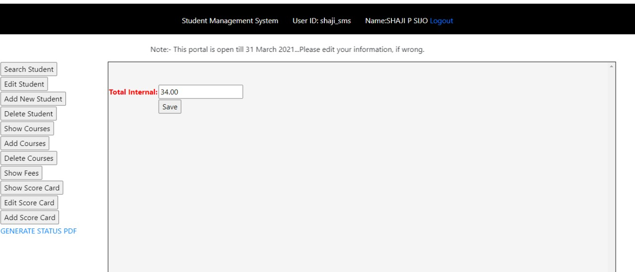

Database before edit

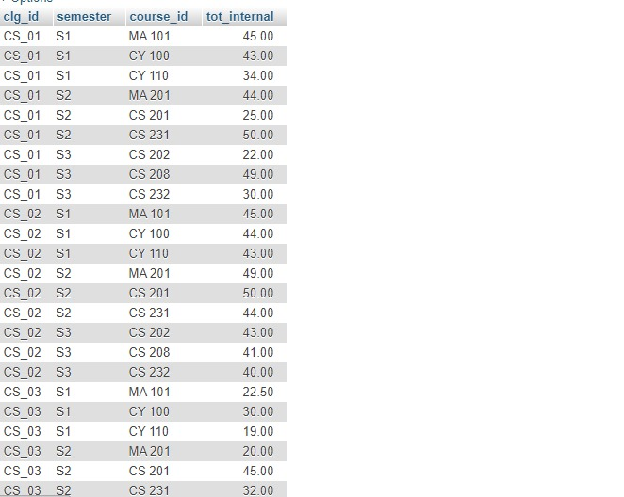

Edit Score card 3

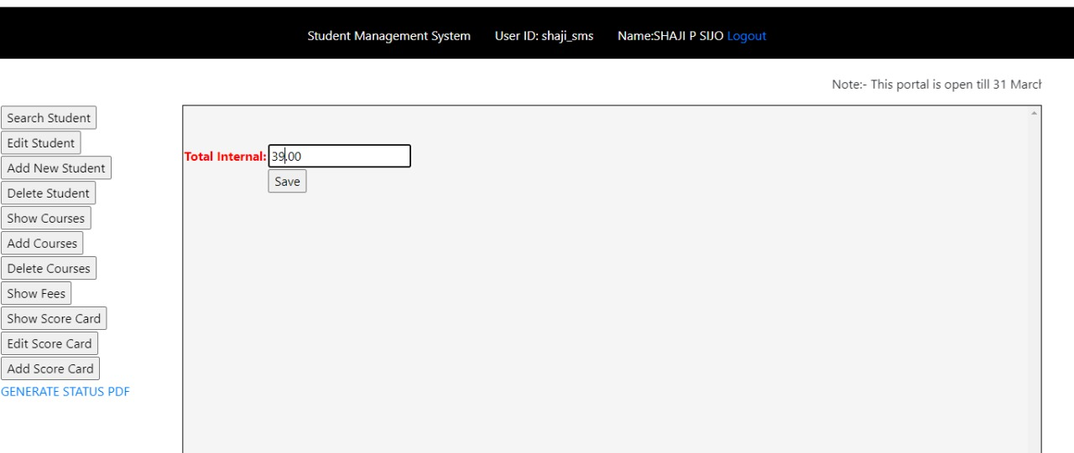



Database after edit

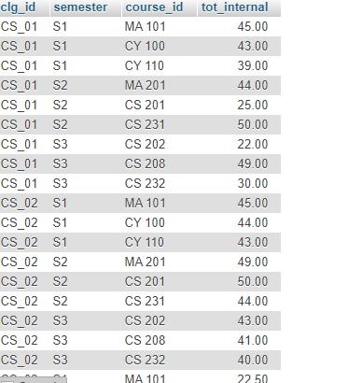

Add score edit 1

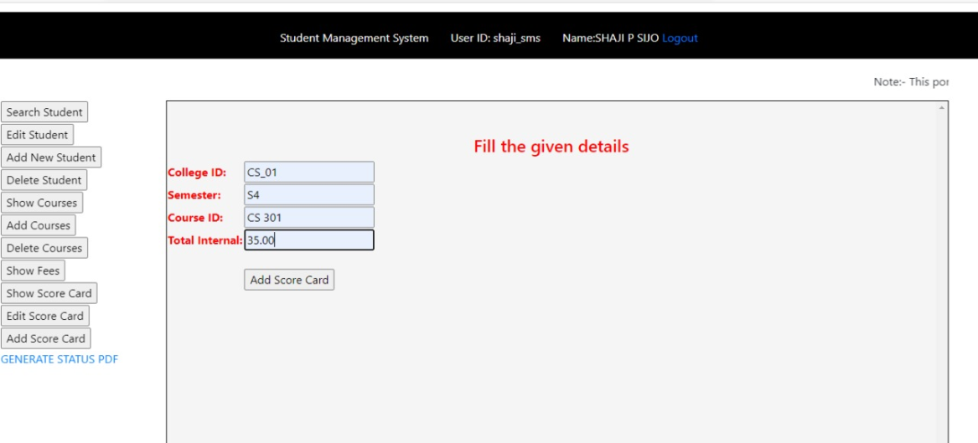



Database after add

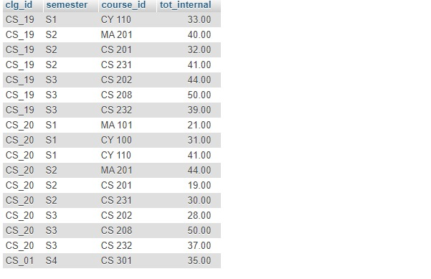

Status pdf

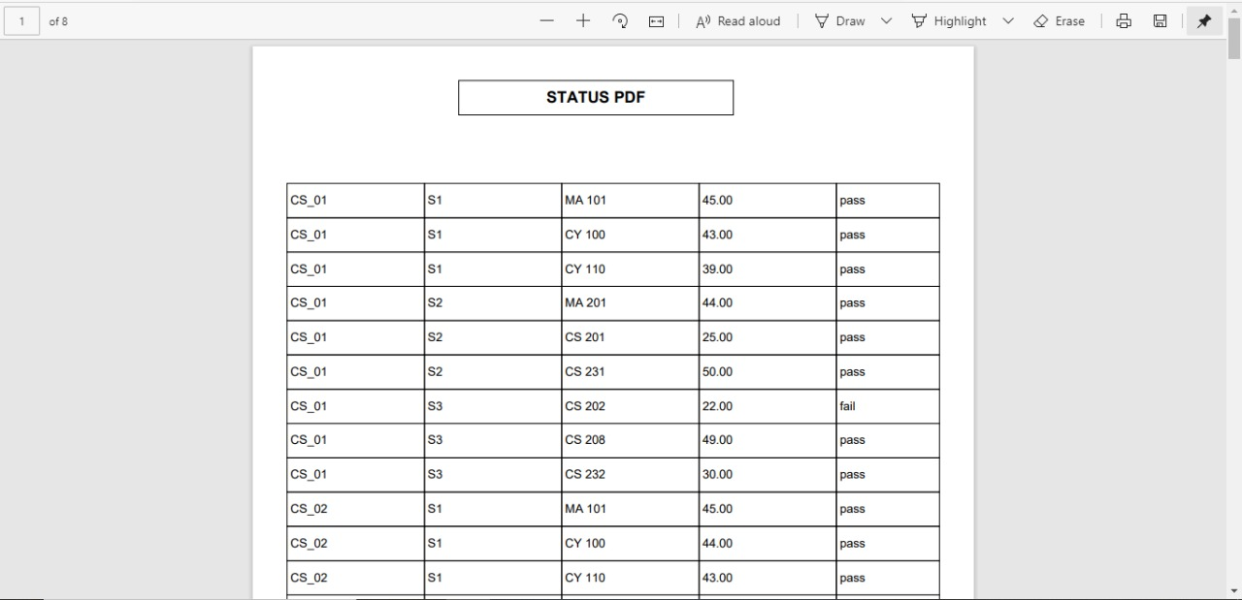



Student dashboard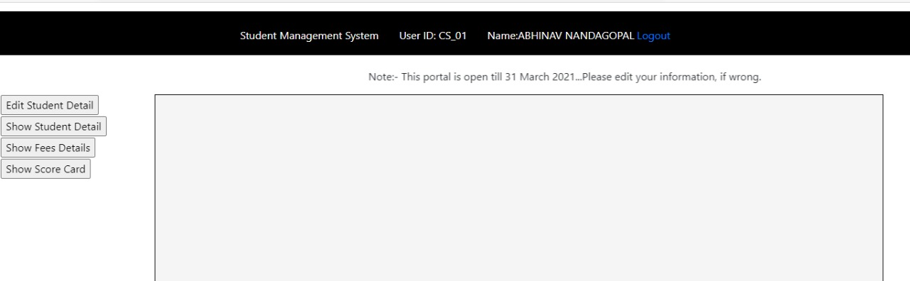

Edit student details

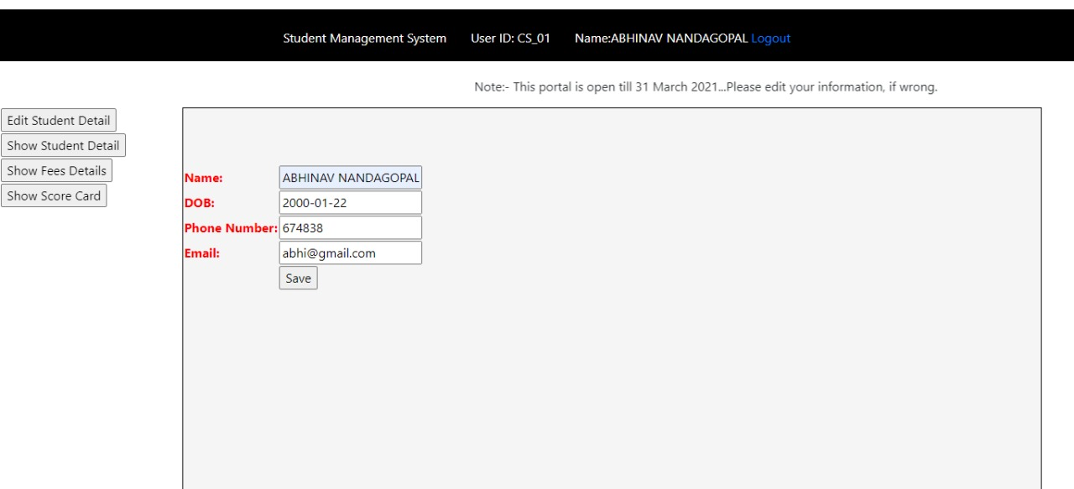

Database before

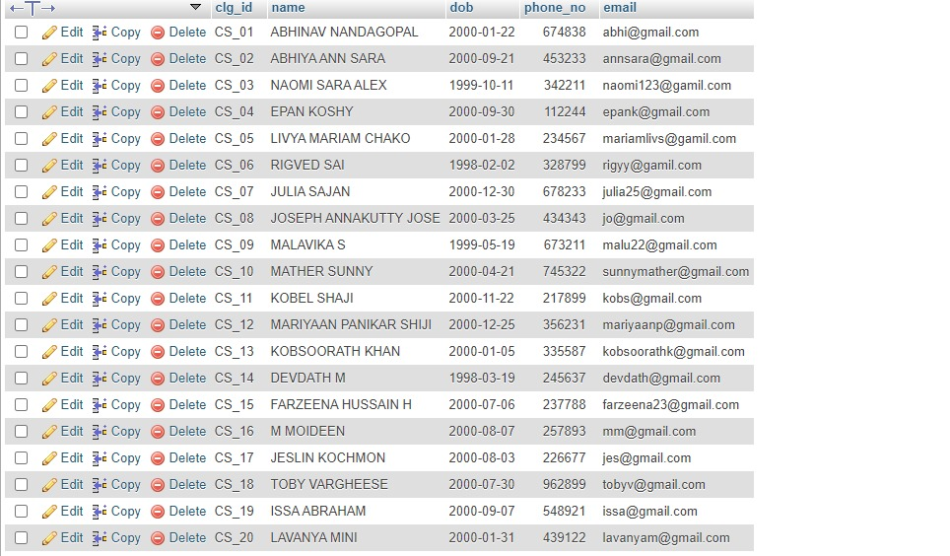



Database after edit

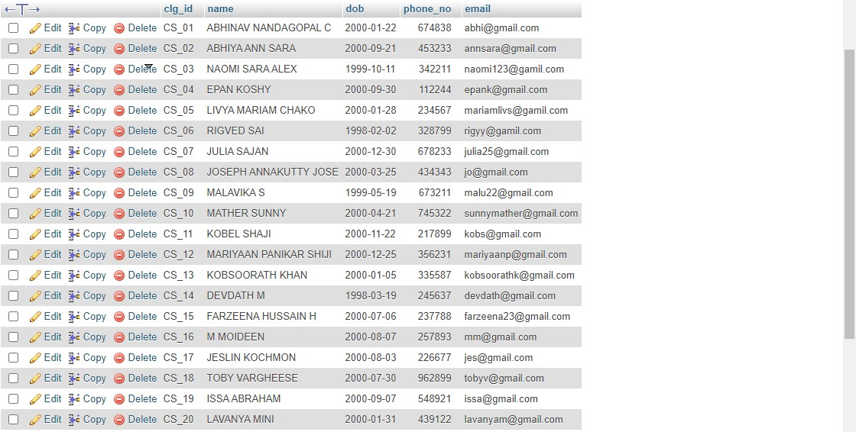

Show student details

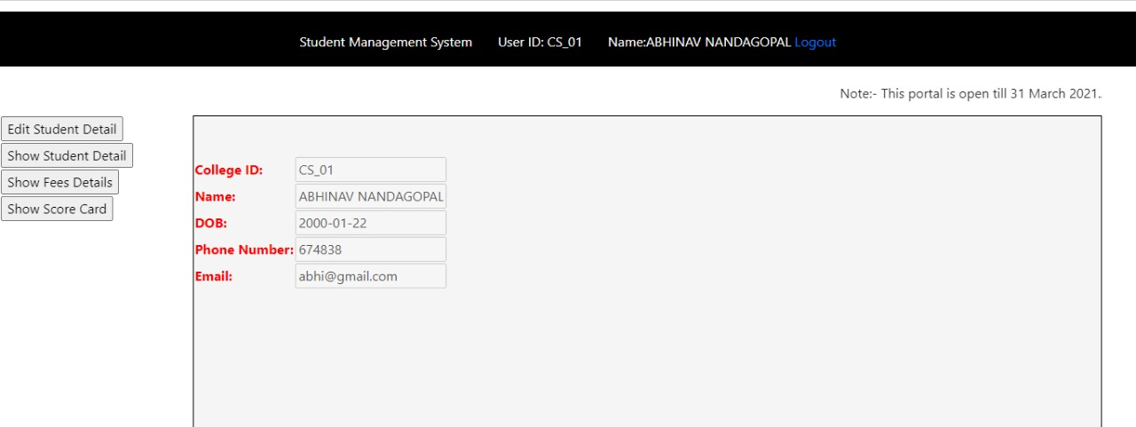

Show fees

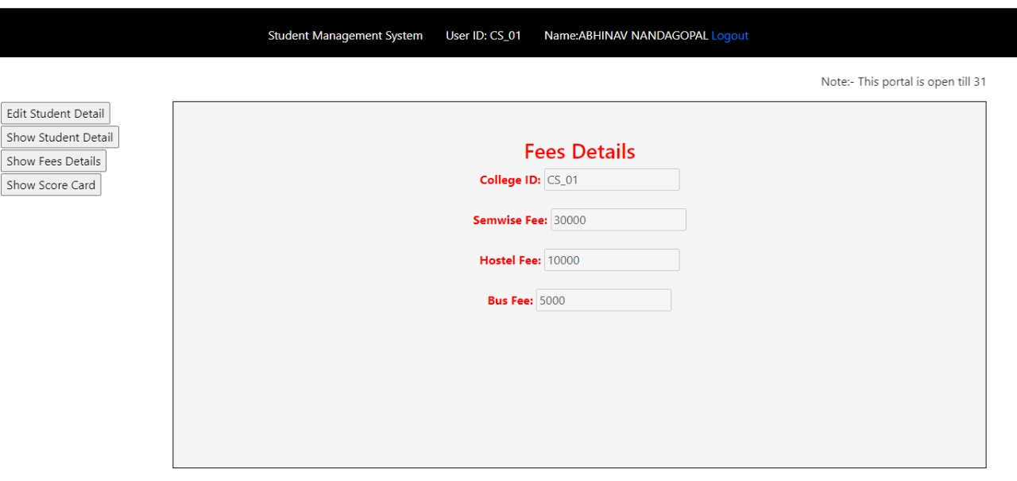

Show Score card

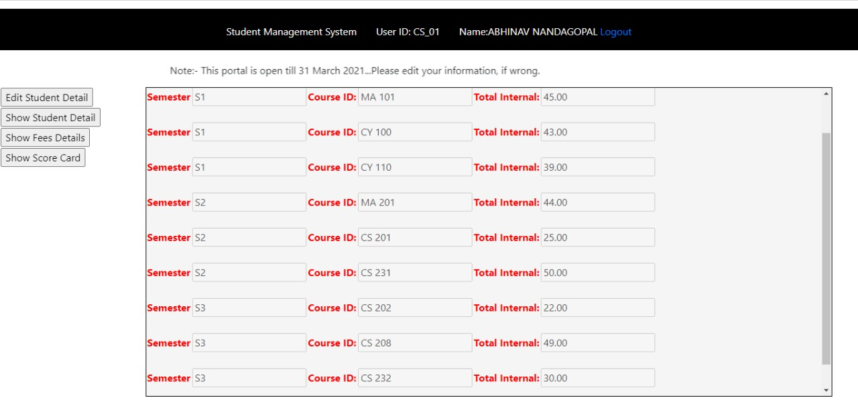

**DATABASE TABLES**

Admin table

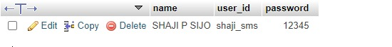

Courses table

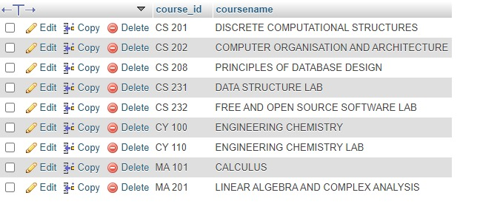

Fees table

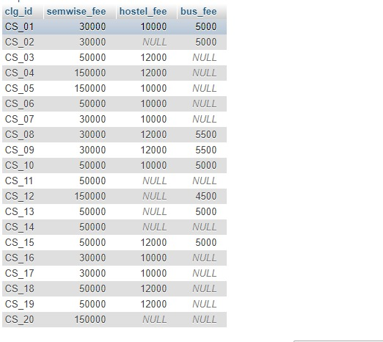

Score card table

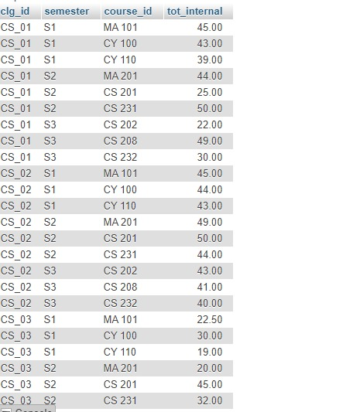

Student table

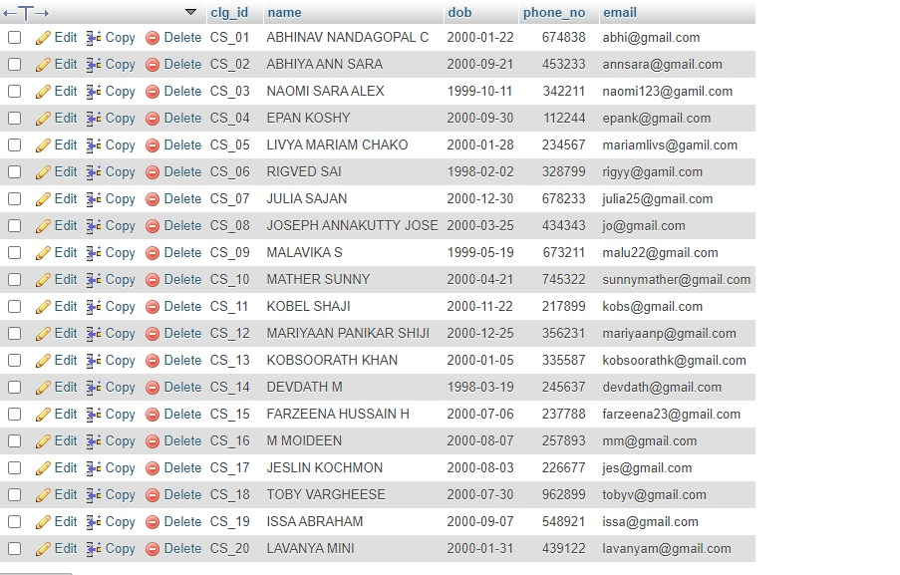

REFERENCES

* <https://youtu.be/Thtp0PKZAuY>
* <https://youtu.be/R2d3W7LQsBs>
* <https://youtu.be/TTriwT13yA4>
* <https://youtu.be/y7NhGwFtdQo>
* <https://youtu.be/w0myUI06kB0>
* <https://www.youtube.com/watch?v=cSjZlDk3zSY>